Important Formula’s:
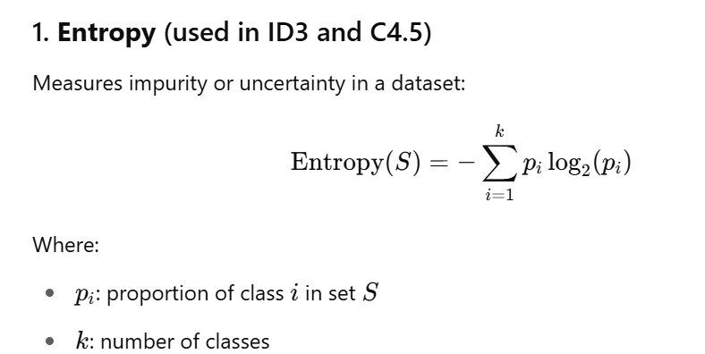

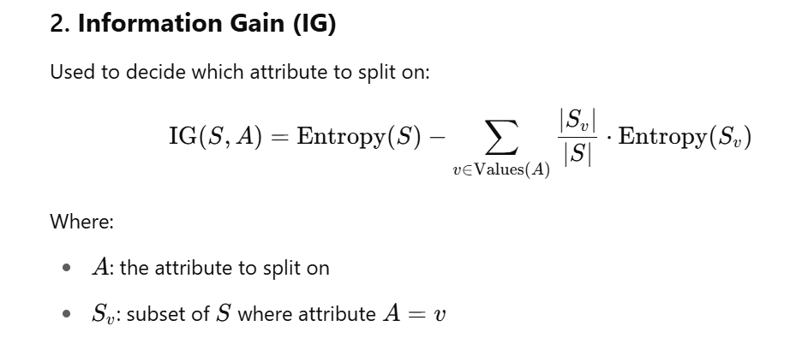

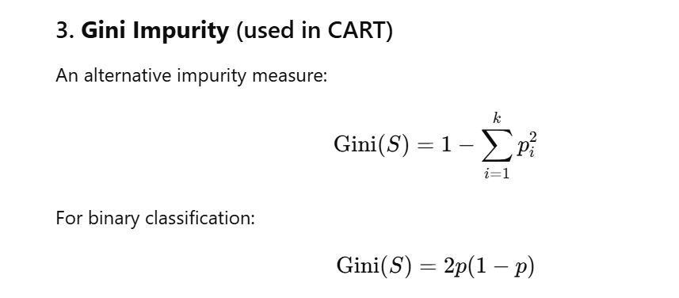
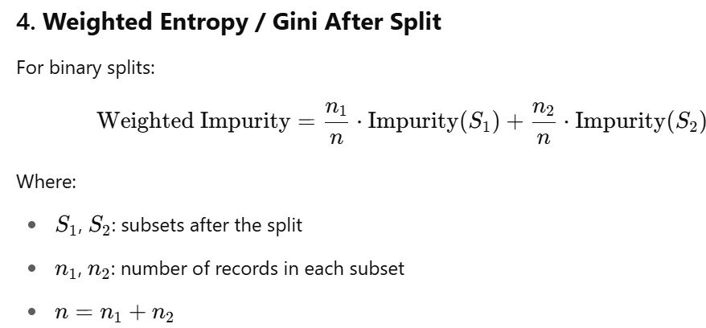

CART : ID3

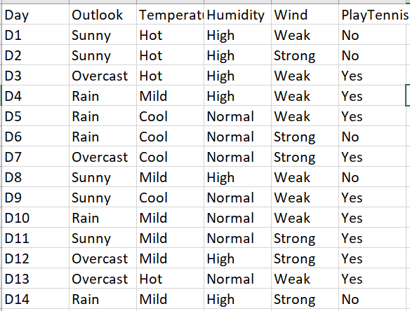

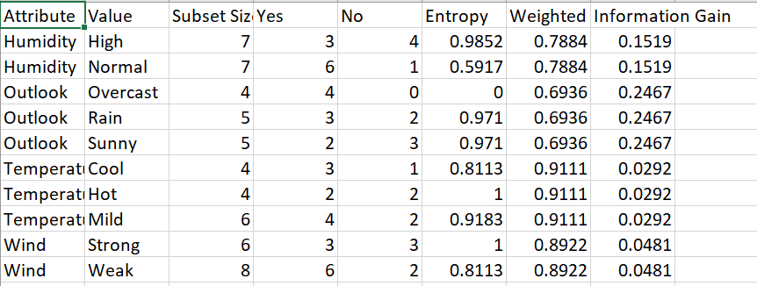

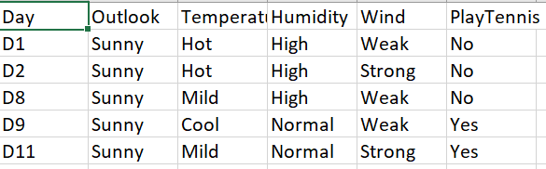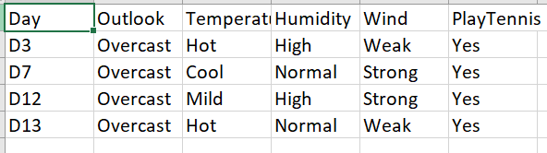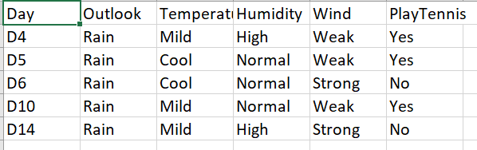

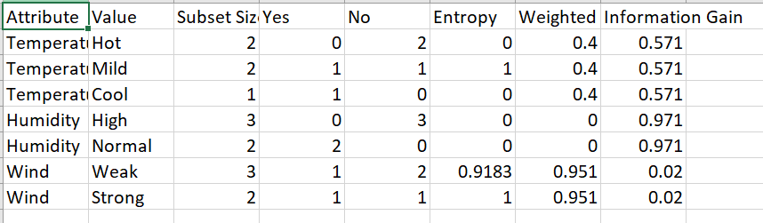
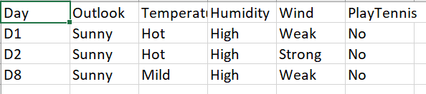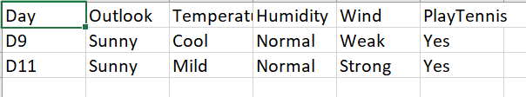
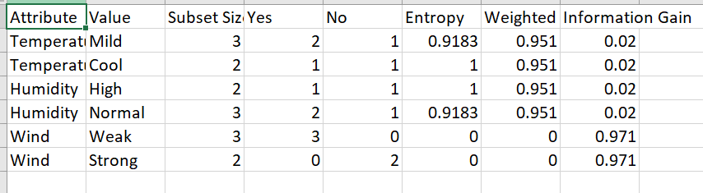
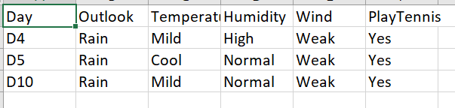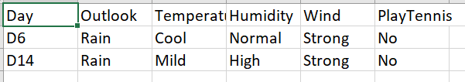
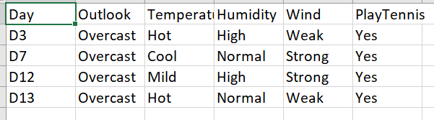


Outlook=Rain

Outlook=Overcast
Overcast=Sunny


Outlook=Overcast


Humidity=high
Humidity=Normal


Wind=Strong
Wind=Weak



CART – sklearn:

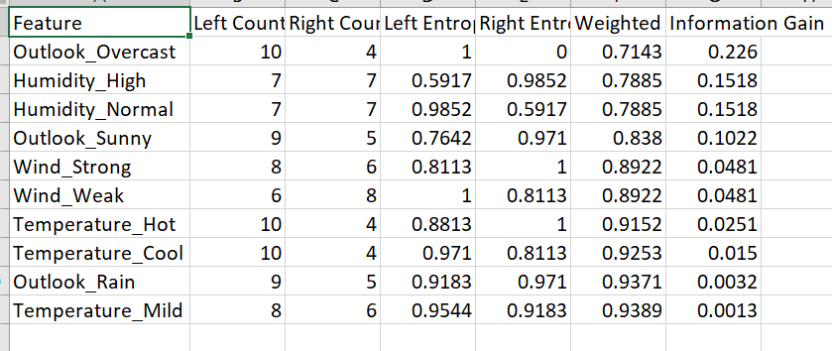
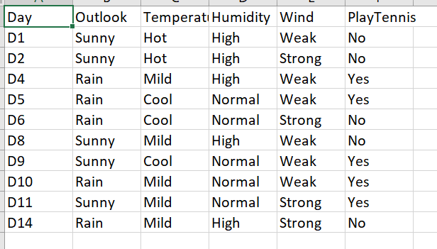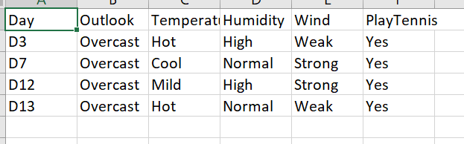
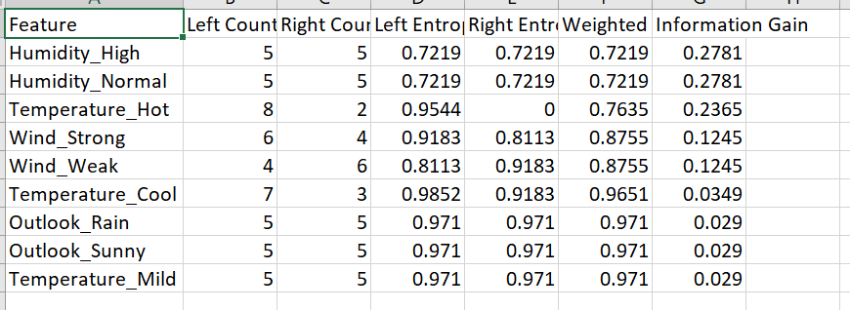

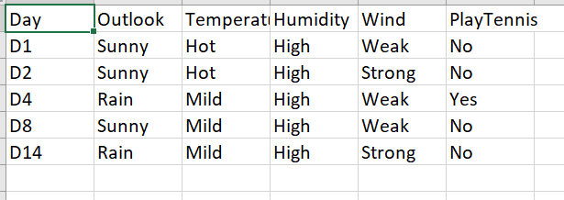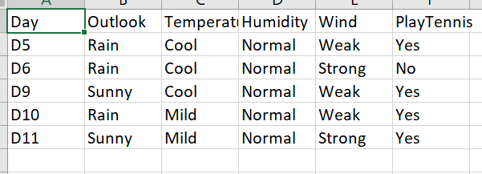

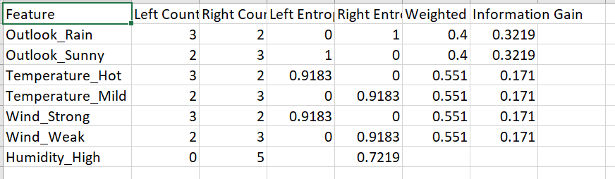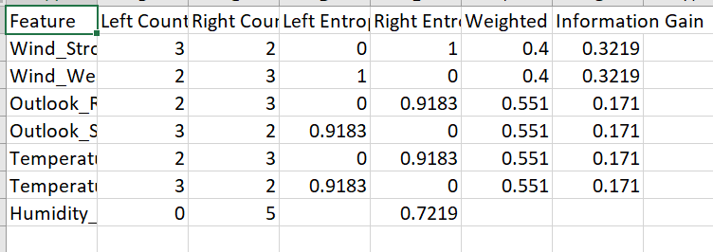

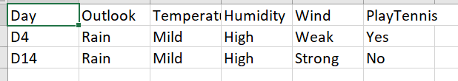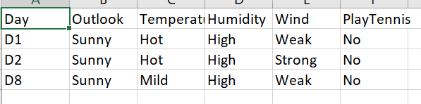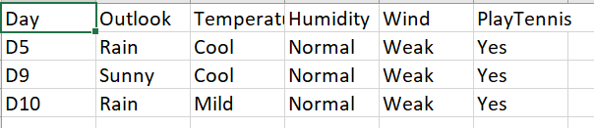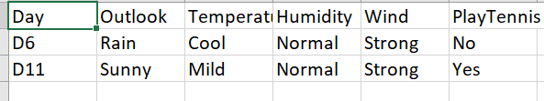
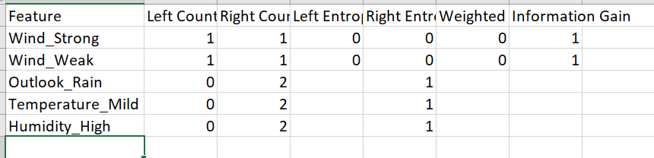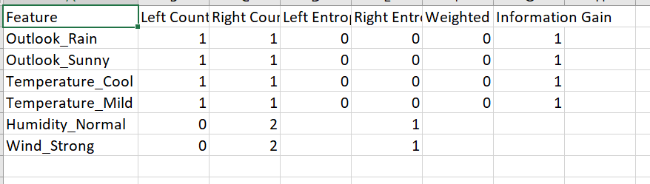
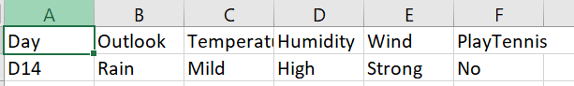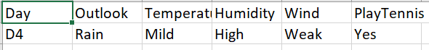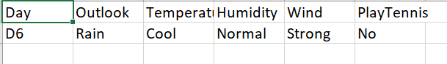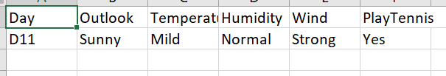


Outlook!=Overcast
Outlook=Overcast

Humidity!=High
Humidity=High


Humidity=Normal
Outlook!=Rain
Outlook=Rain
Humidity!=Normal

Outlook!=Rain
Outlook=Rain
Wind!=Strong
Wind=Strong



CART – Numeric :
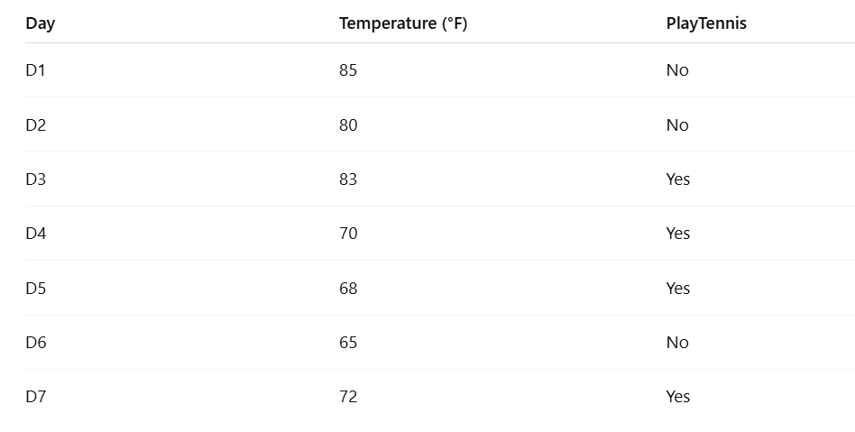

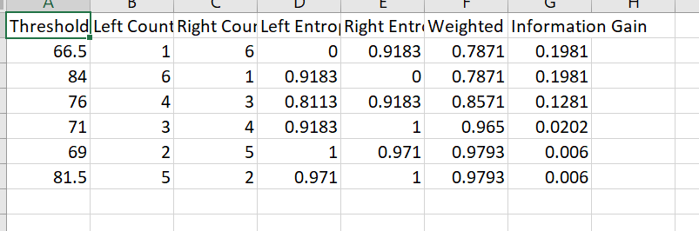

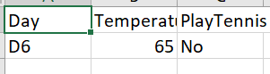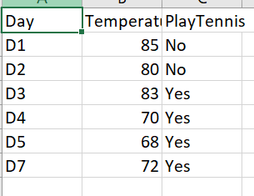

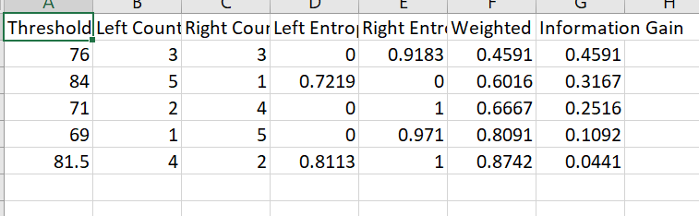

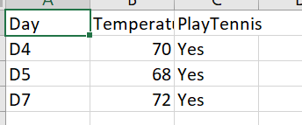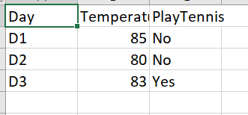
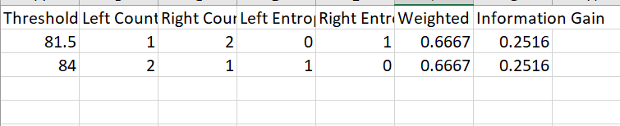

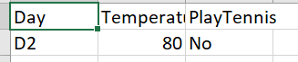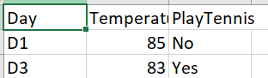



Temp
<=66.5
>66.5

>76
<=76


>82
<81.5


<=84
>84

Adboost:
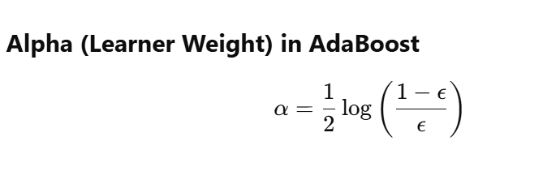
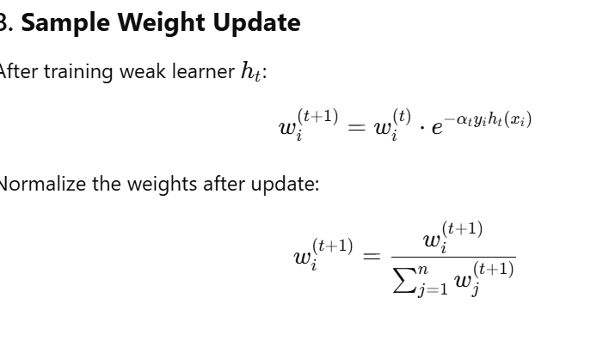
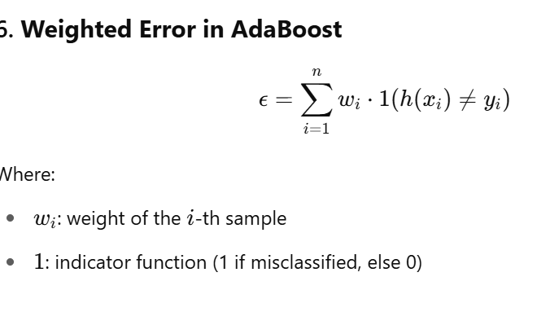
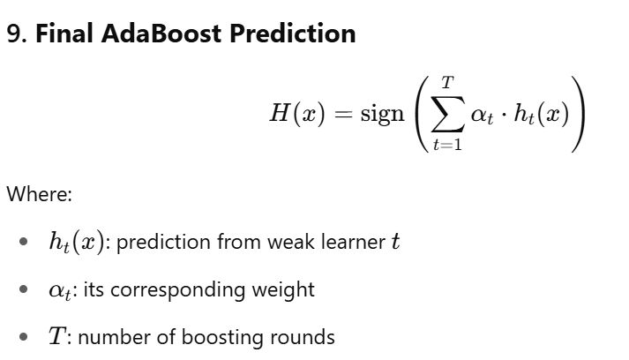

Example: Numeric:

Weights initialization: 5 records -> 1/5 = 0.2 equal weights

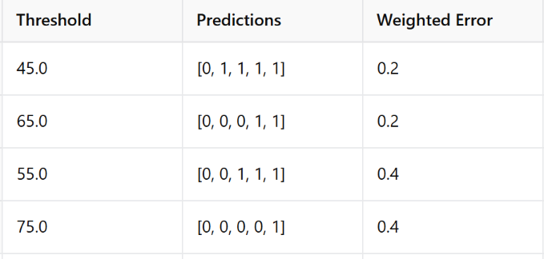
At threshold 45, we have least weighted error: Epsilon=0.2
Now we calculate alpha = natural log .05*ln(1-0.2/0.2) = 0.69
New weights update:
For correct prediction: y*h(t) = 1*1/-1*-1 = +1 , for wrong prediction y*h(t) = 1*-1 = -1
New Weight = old weight * e^-alpha for correct predictions
New Weight = old weight * e^alpha for wrong predictions
Sample1 correction prediction:
New weight = 0.2*e^(-0.69) = 0.2*0.5 = 0.1
Sample3:
New weight = 0.2*e^(0.69) = 0.2*2 = 0.4
Normalization = 0.1+0.1+.4+.1+.1 = 0.8
Diviide by 0.8 to get new normalized weights

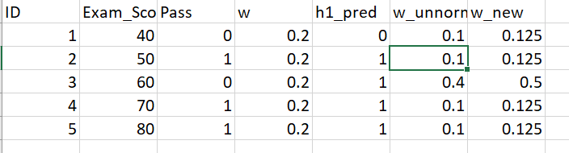

Round 2:
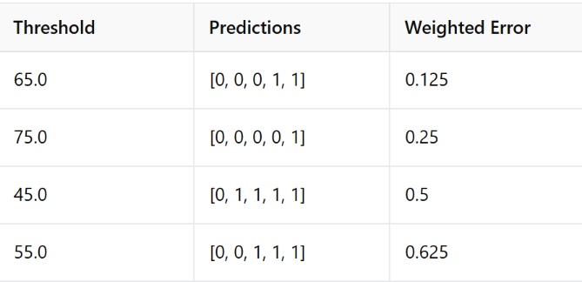

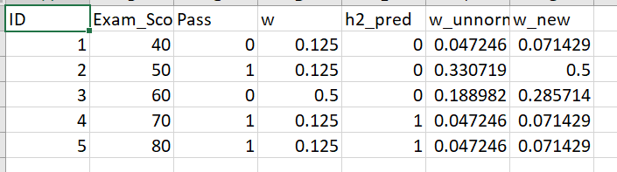
Round 3:
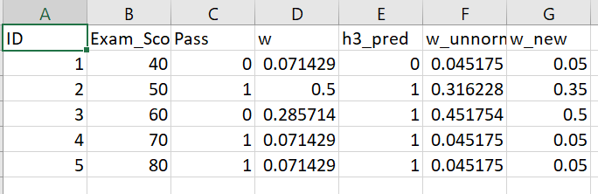

Final Prediction combining results:
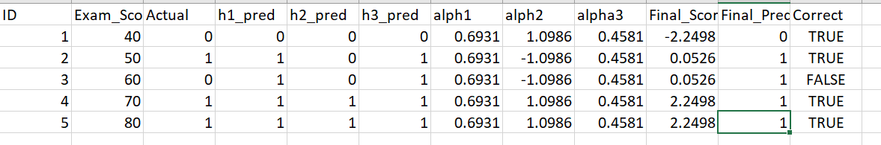

Gradient Boosting:
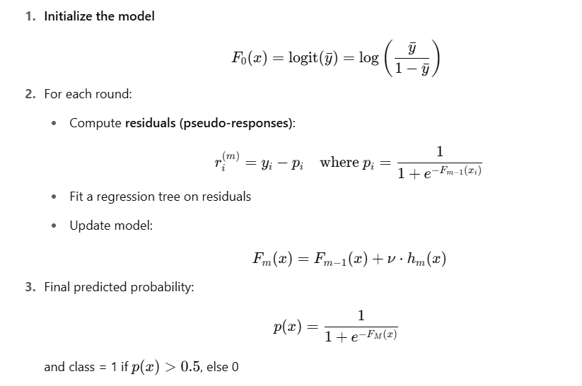
Step 1:
Y^ = mean of target class = 1+1+1+0+0 = 3/5 = 0.4
Initialize Fo = ln(y^/1-y^)
Initialize po = 1/1+e-f0 = 1\1+e^(-0.4) = 0.6
Residual = Actual – Po
Build Decision Tree using X and residual as target
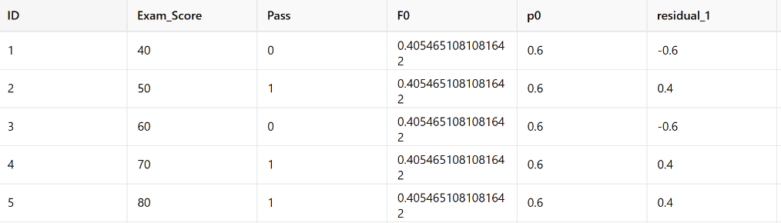

After 1st run:
F1 = F0 + learning_rate*h1(x)
For the 1st row: .405 + 1*(-.266)= .138
P1 = sigmoid(F1)
Residual2 = Actual – p1
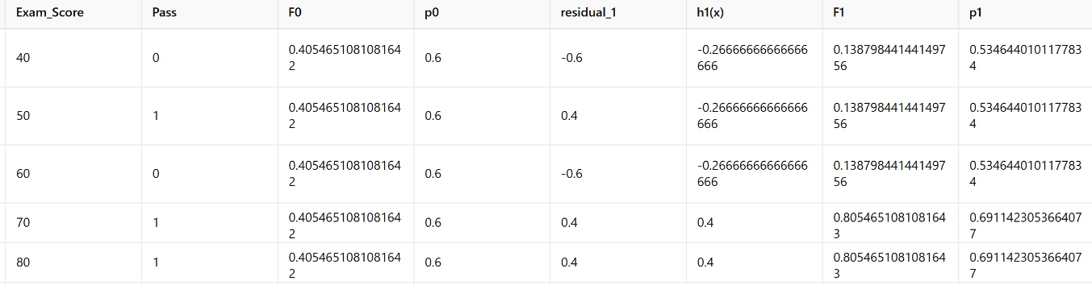

After 2nd run:
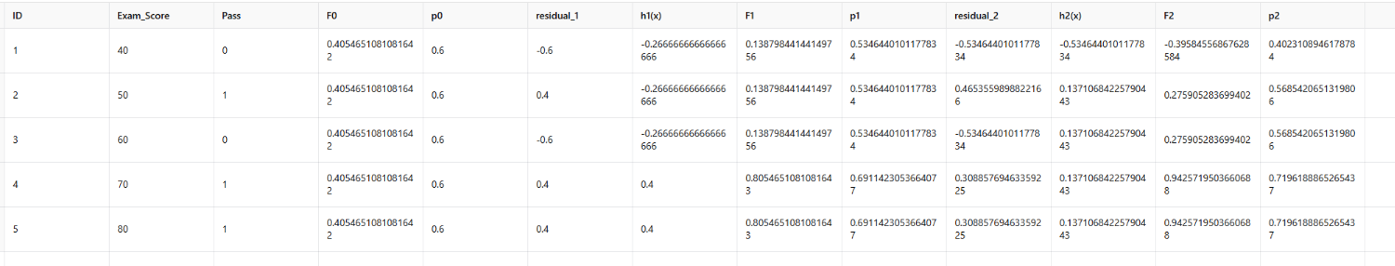
Final Prediction:
